Project - 2

Tasks To Be Performed:
Create the app and a data model for the application. This simple application requires only a few custom objects with a small number of fields. Modify the user interface on the browser and on the Salesforce mobile app using page layouts, compact layouts, and global actions. Implement business logic using formulas, validation rules and a process builder. Build reports and dashboards to track the status of supplies and analyze how the resources are being managed on the following specification.
Data Model: You would require 3 custom objects.
Station: This will be our main object that tracks the status of the project, its supplies and resources. This will have the following fields:
● Name
● Sumofresources (roll up summary field)
● Project status Master detail relationship with the rest of the objects
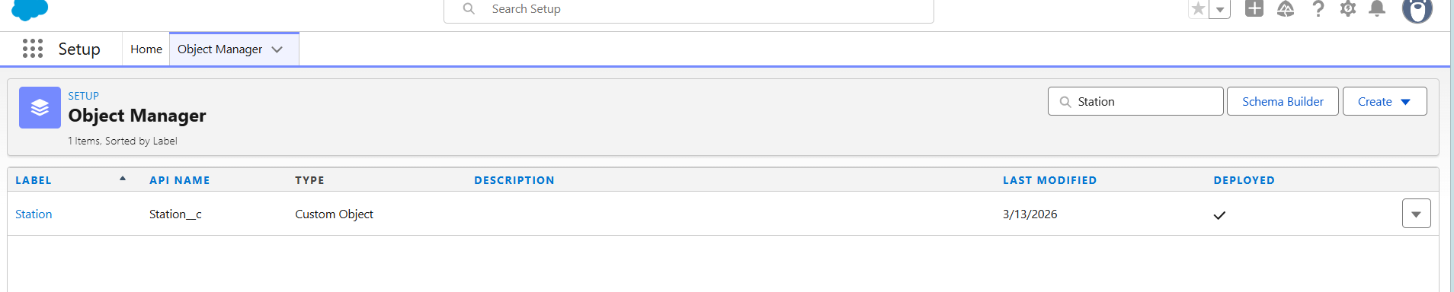

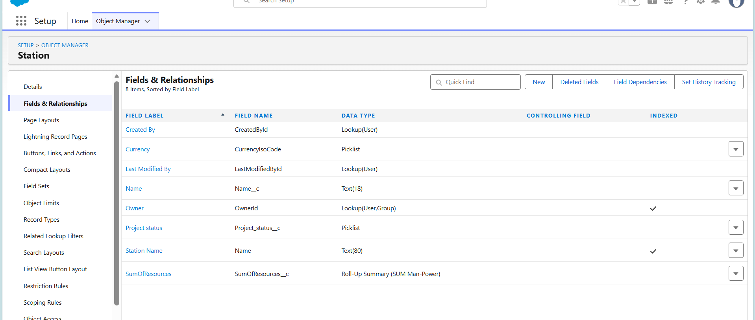

Man-Power: This custom object to track the number of people working on the construction project and how much time they are committed to it. This will have the following fields:
● Shift
● Department
● Total number of people in a department
● Percentage utilization of manpower
● Total crew
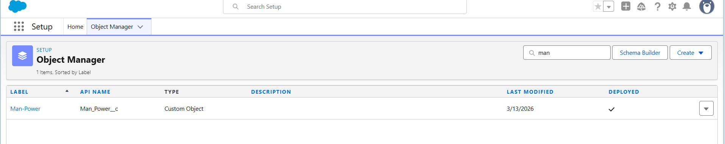

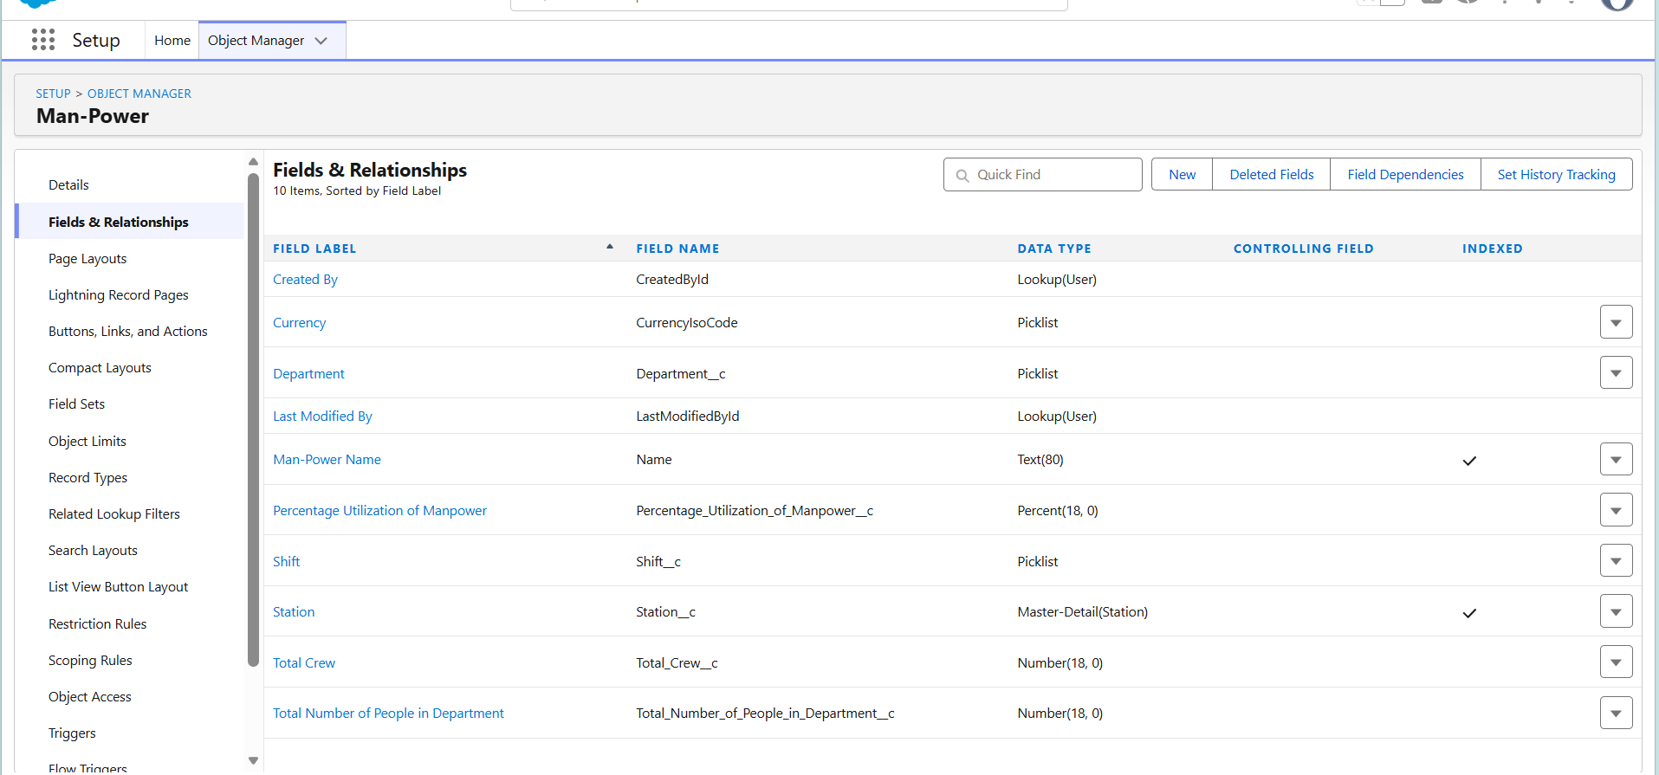

Supply: We'll use this object to track our supplies and their costs. This will have the following fields:
● Supply name
● Cost
● Quantity
● Total cost

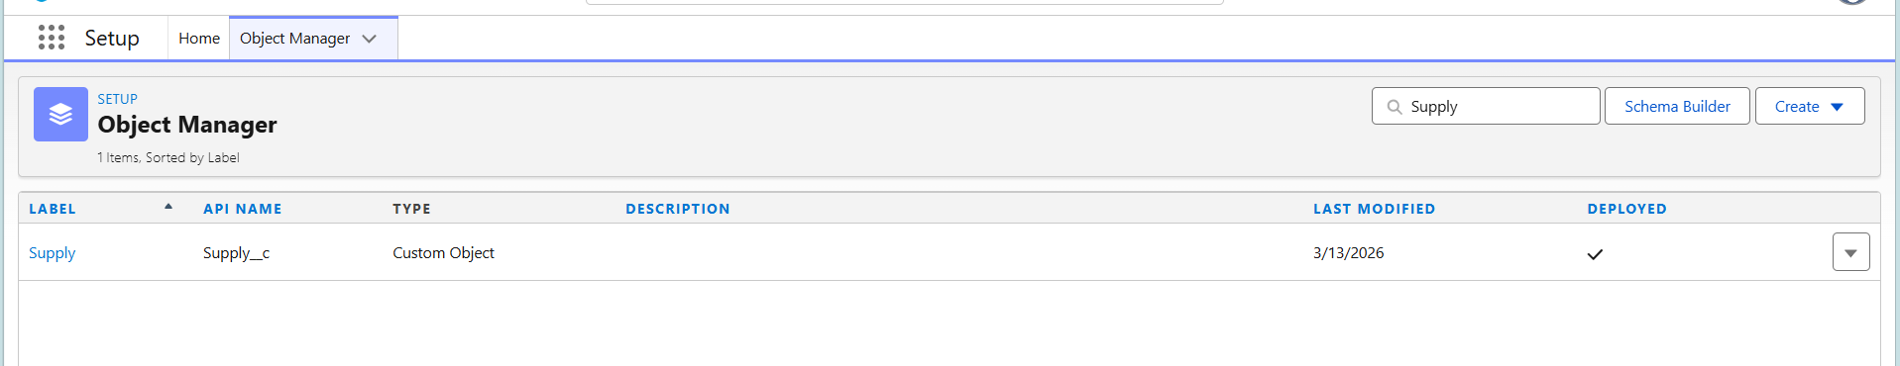

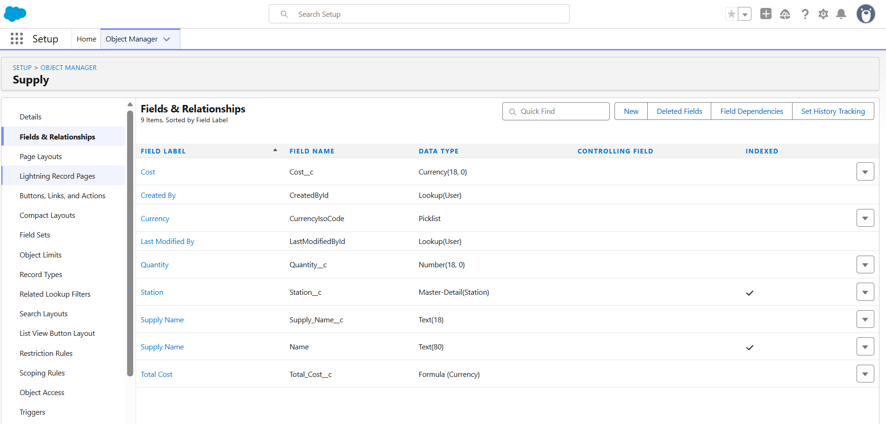
Automation process to meet the following conditions:
● Standard regulations require that manpower used should not be greater than 80% at any time however the company feels 50% of manpower is required at all times so create a process that sends system administrator an alarming mail in event of utilization being greater than 80 or less than 50%.

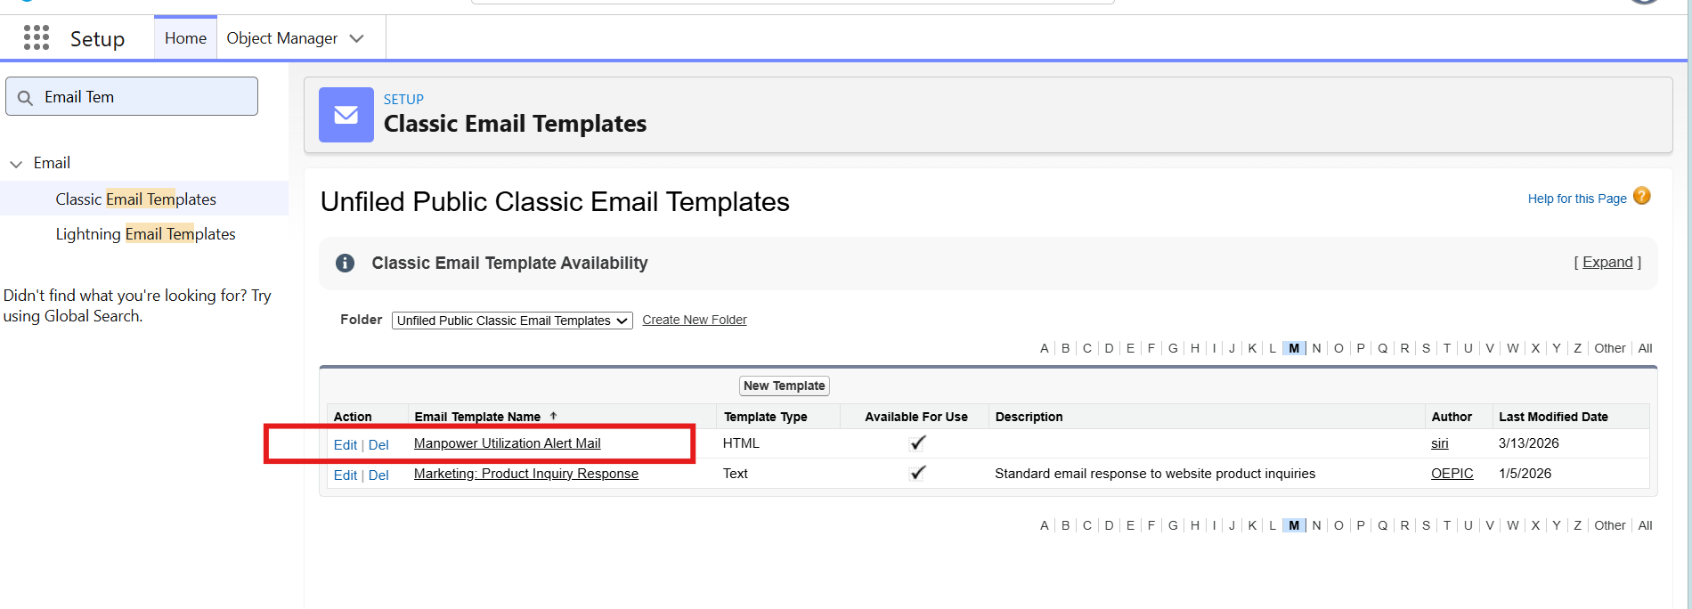

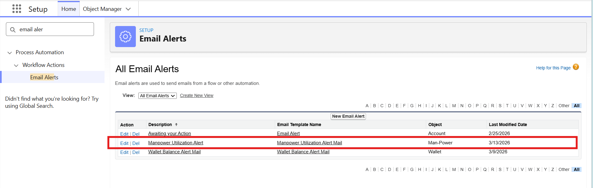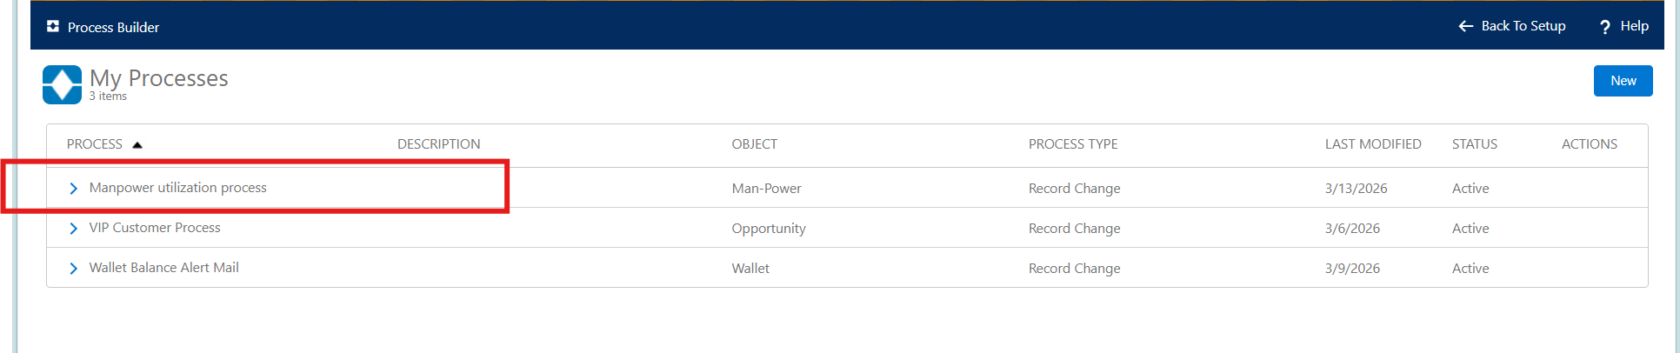
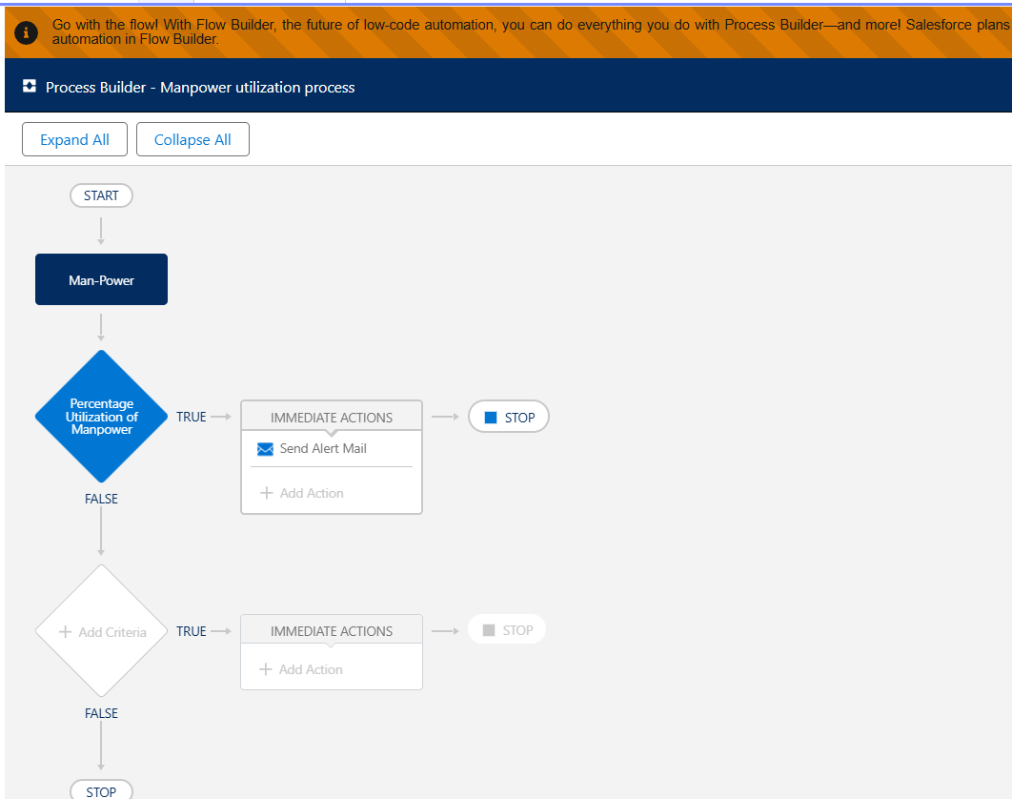
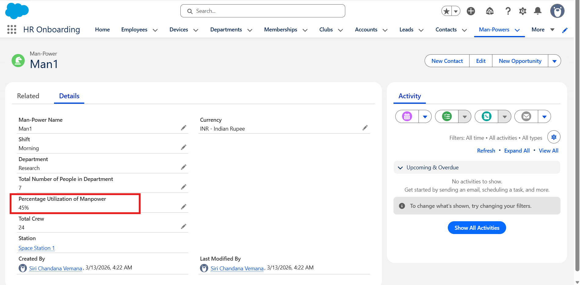

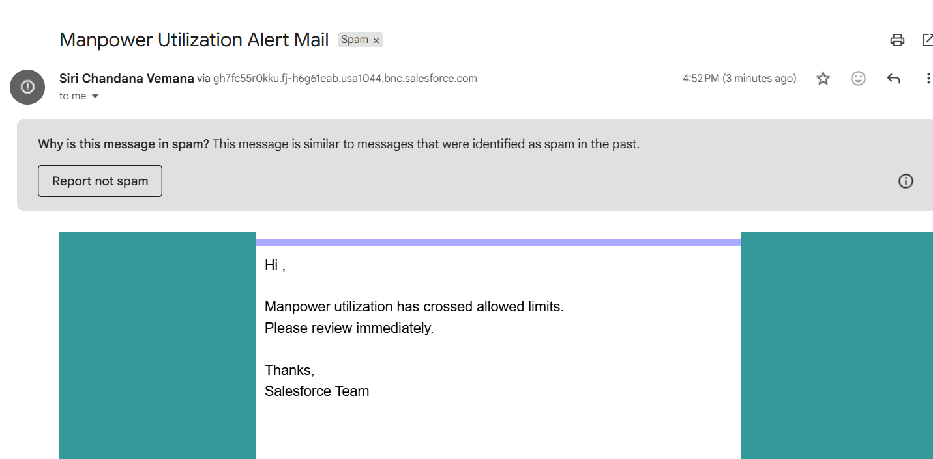

● Create a process to create records for the supply and manpower.
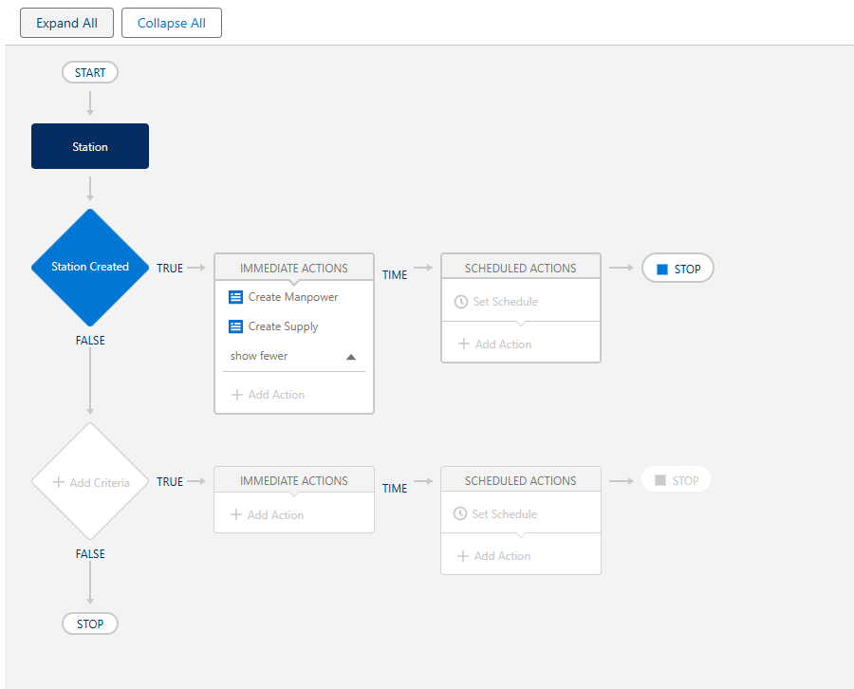

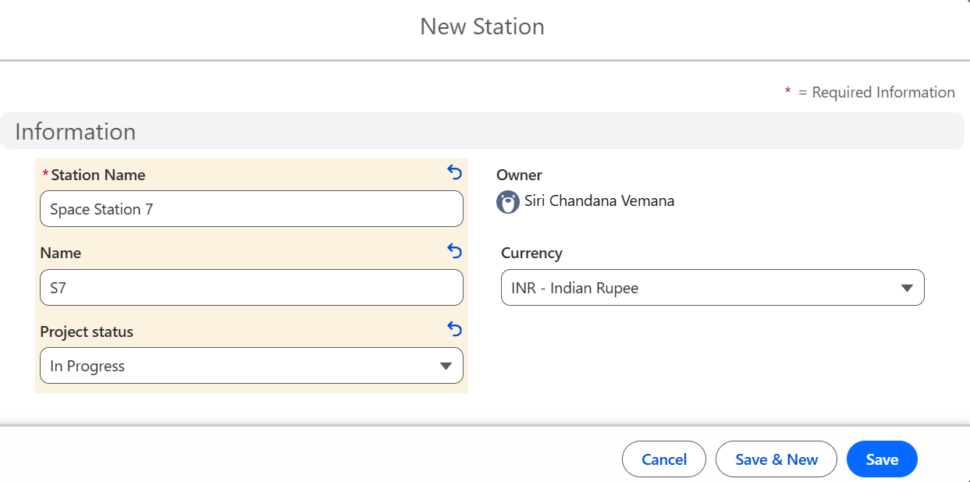

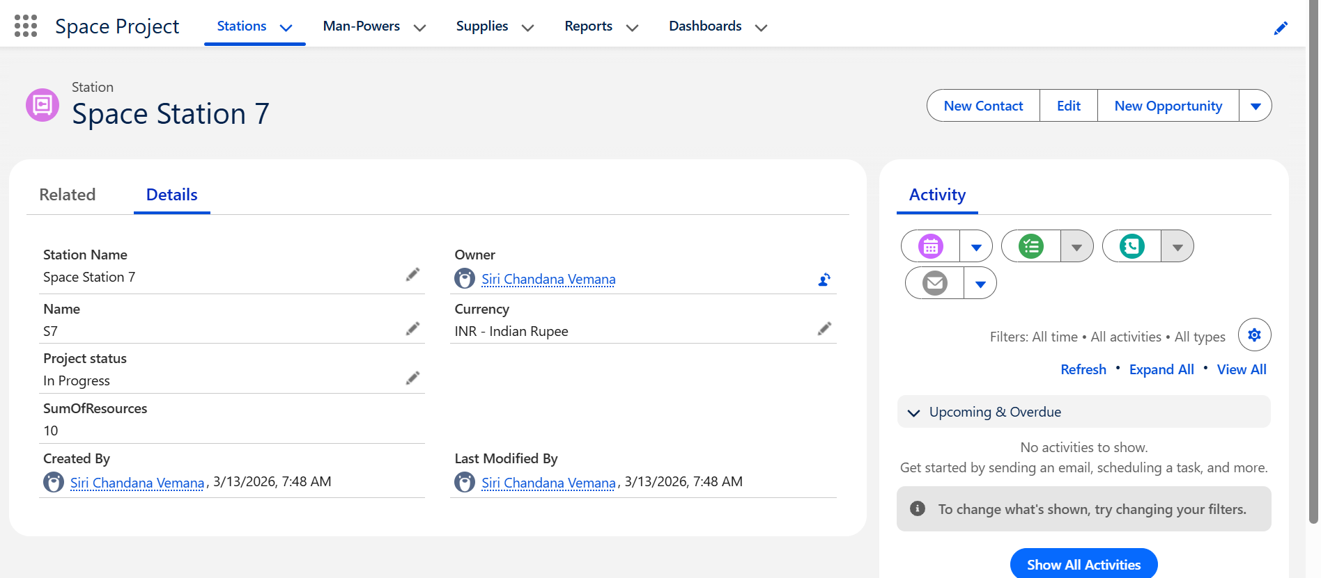

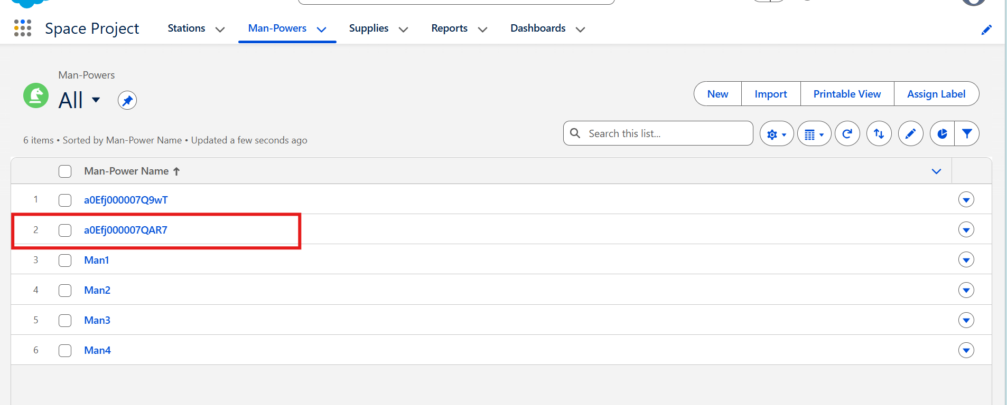

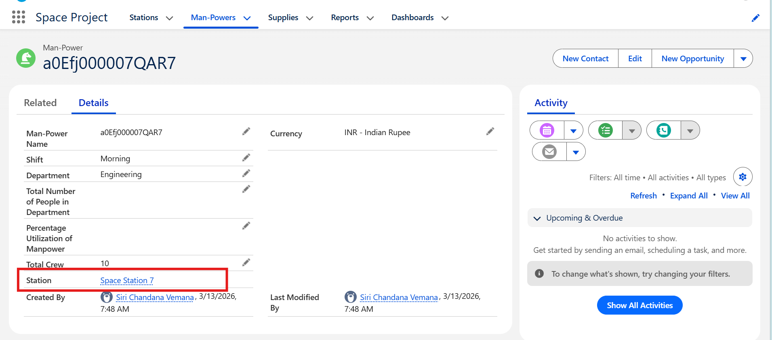

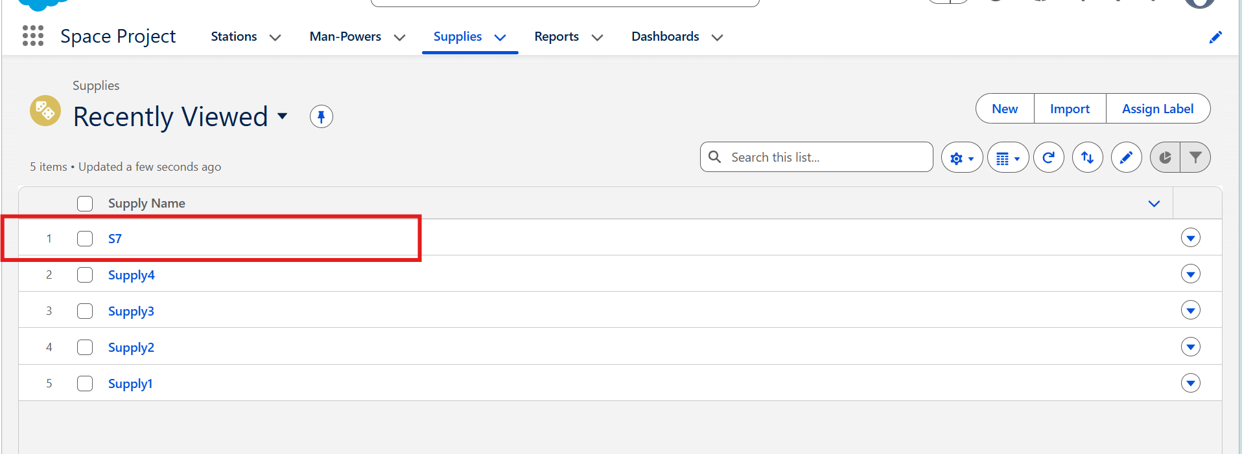

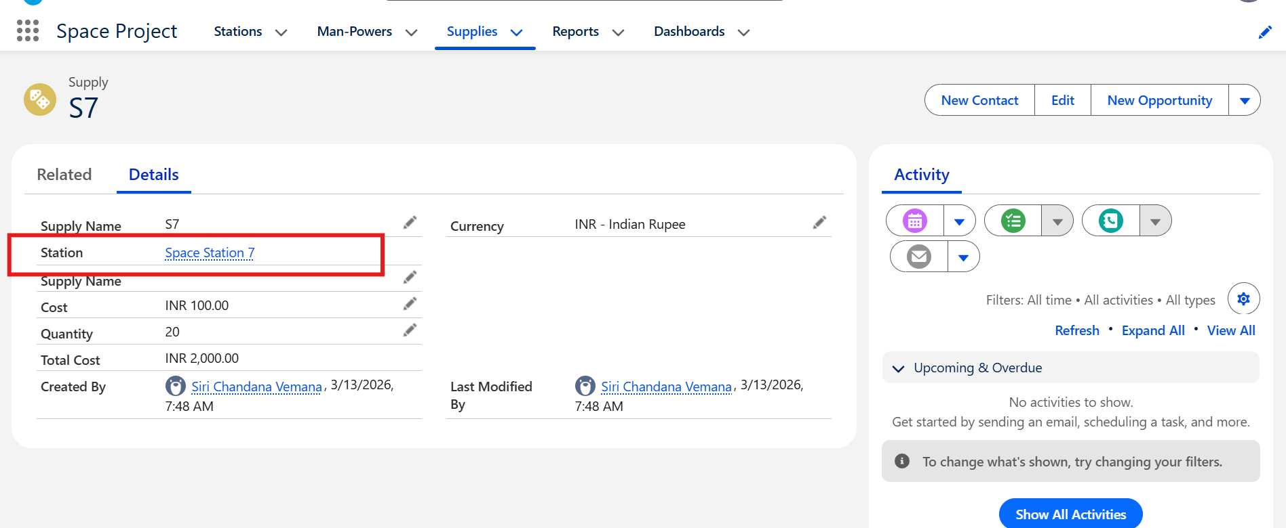

Reports and dashboards:
● Create a Report for supply costs, man power utilization, status of project completed.
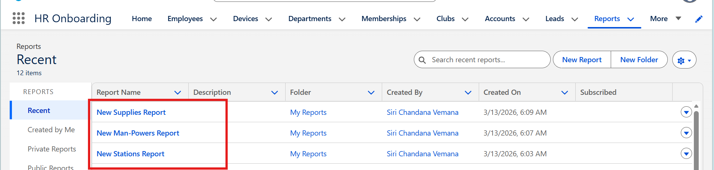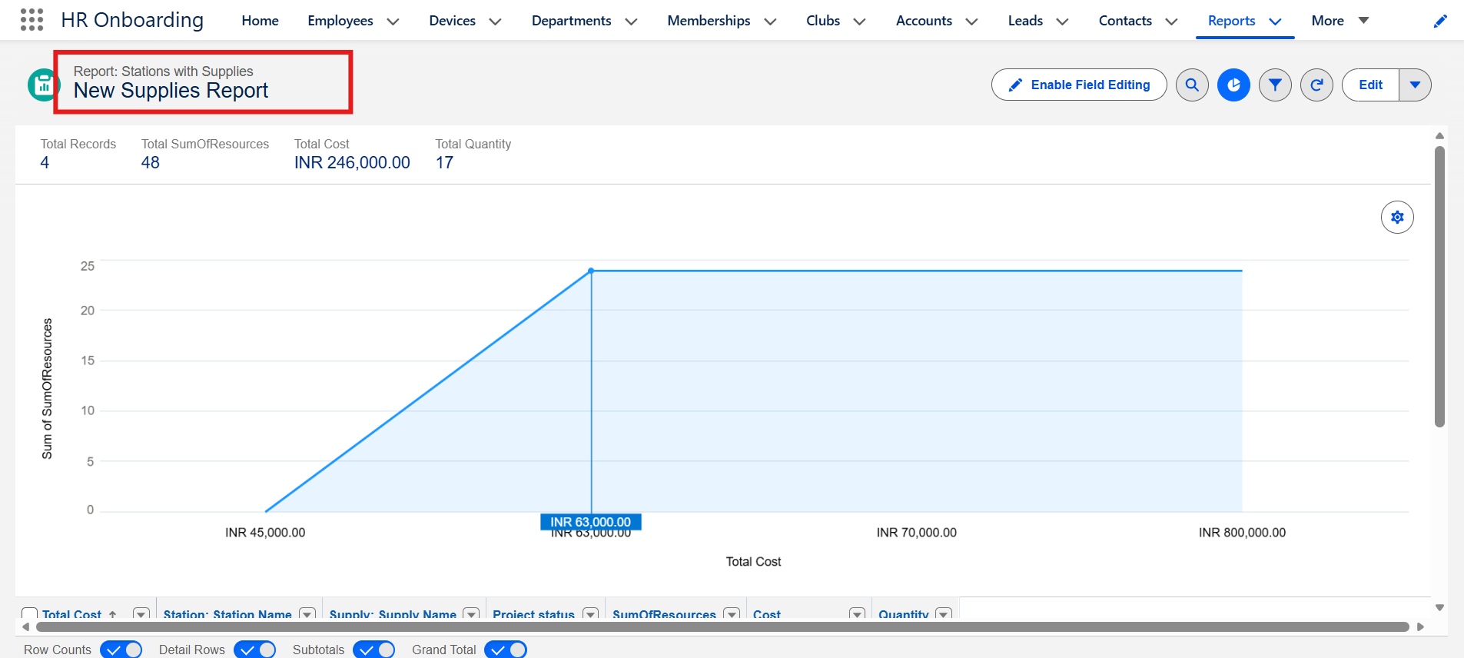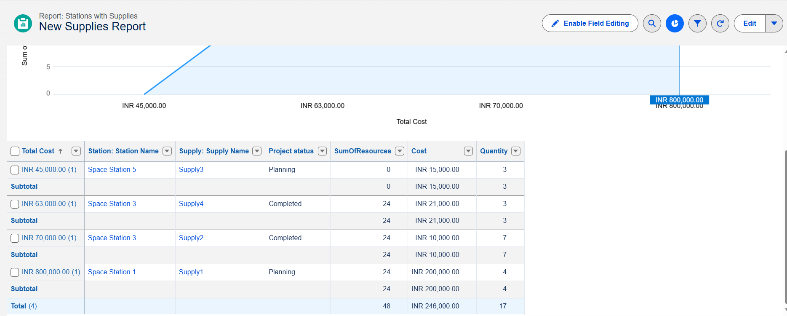

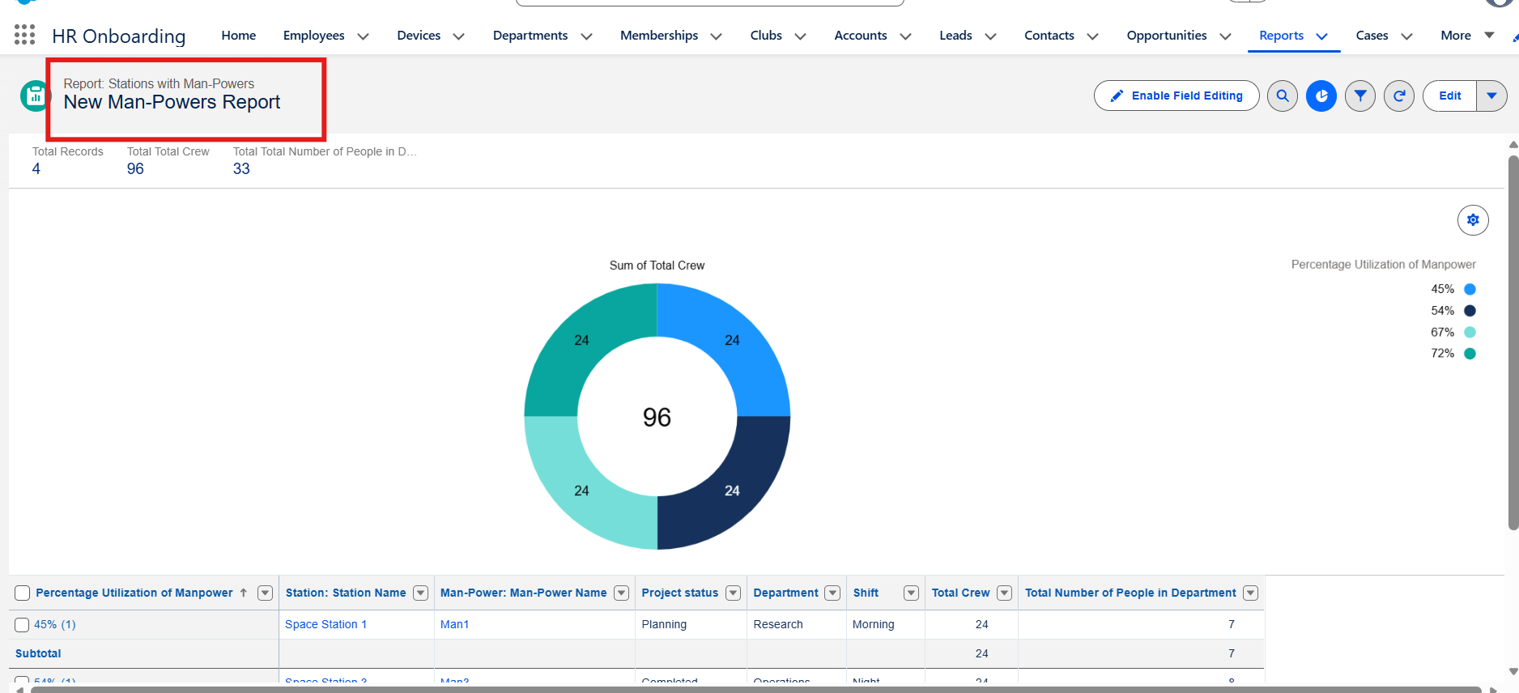

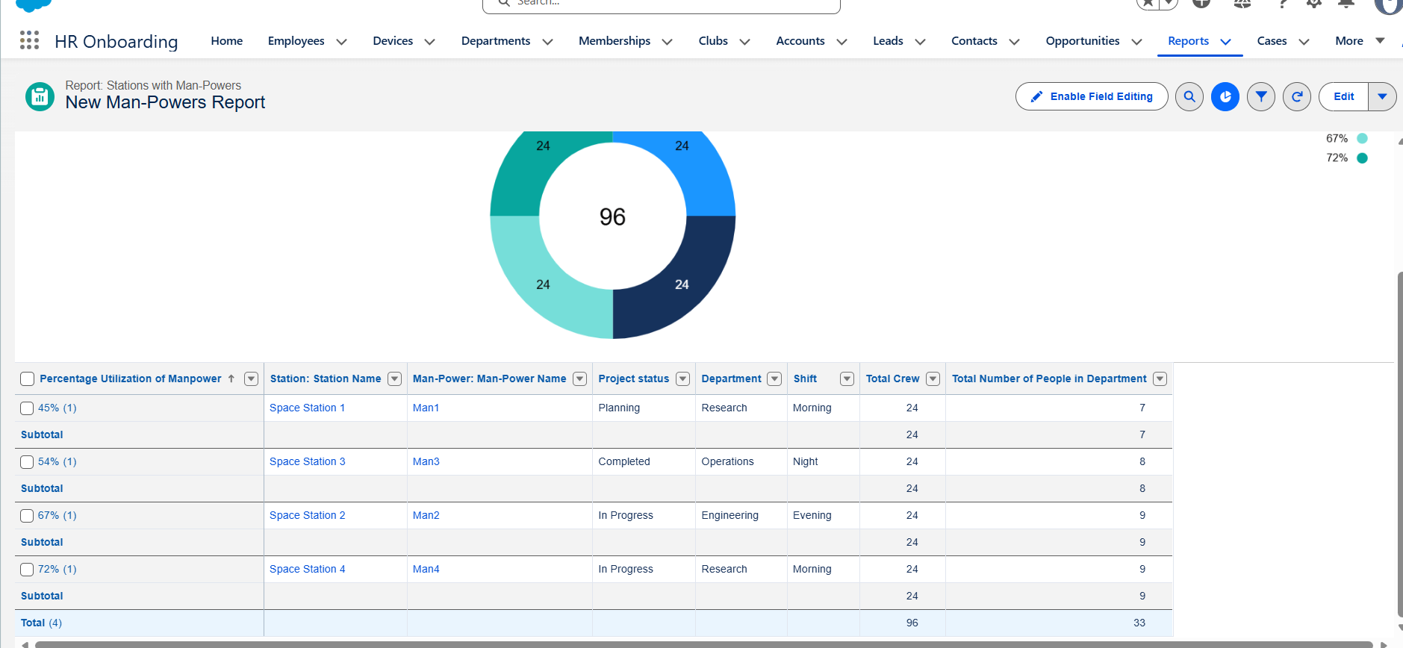

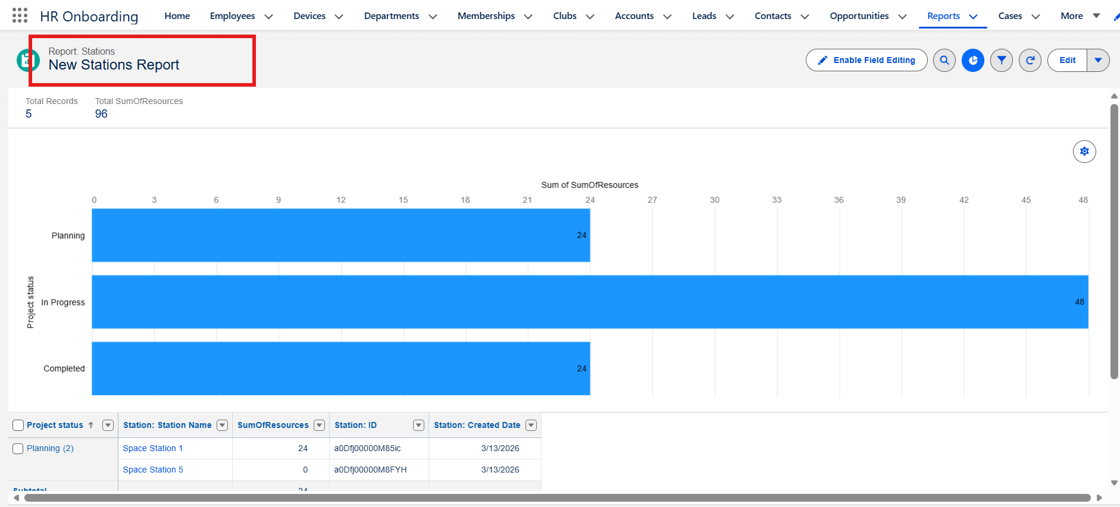

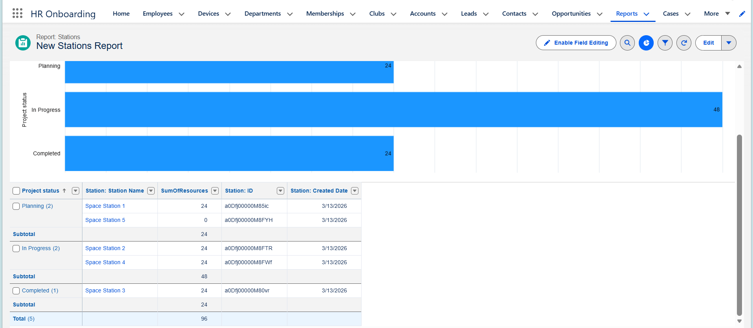

● Create a Dashboard to display reports.
